How to get your #include “std_lib_facilities.h” working if you are using Visual Studio 2010 express
Your first “Hello world” project, you must have a program opened.
- Open Standard library access header from http://www.stroustrup.com/Programming/
and Copy to Notepad. Save as std_lib_facilities (fig. 6)

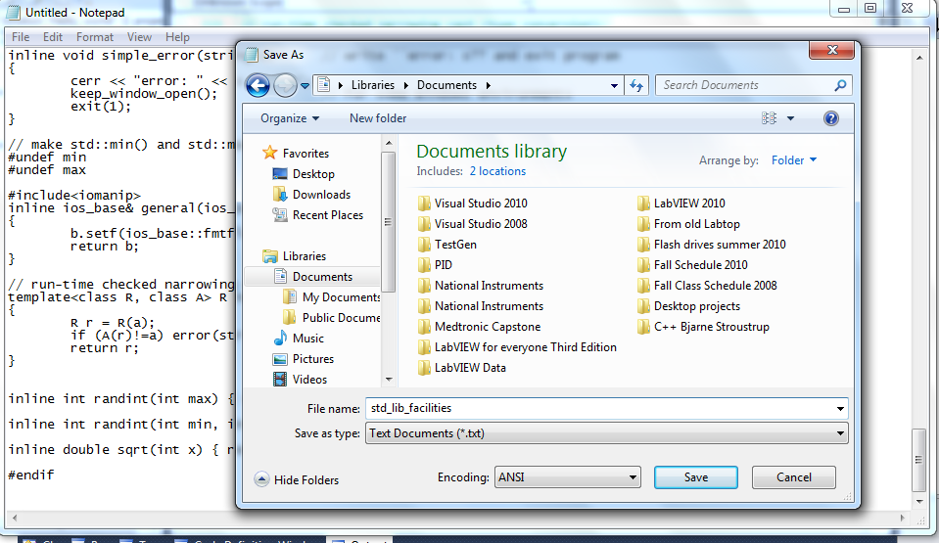
Fig. 6

- For your program to work you must create a header file from your saved std_lib_facilities text file.
- With your first Hello World program opened, you must past a copy of your std_lib_facilities text file to the header folder. (fig. 7, fig. 8) NOTE: there are better ways but I found this easy for people who are creating their first program.
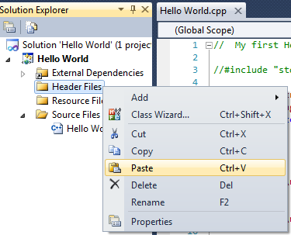
Fig. 7
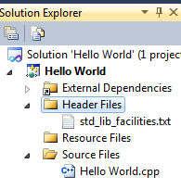
Fig. 8

- You must now rename your file extension, instead of .txt change the extension to .h (fig. 9)
- Right click on std_lib_facilities and click rename; remove the txt and insert h, you will see it changes to a .h header file( fig. 10)

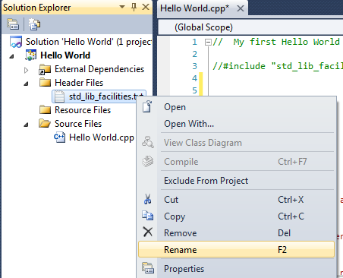

Fig. 9

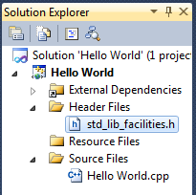
Fig. 10

- You will need to copy this new std_lib_facilities.h (fig. 11) and place it in Visual Studio 2010 folder (fig. 12) you will see the file type is now a C/C++ header (fig. 12)
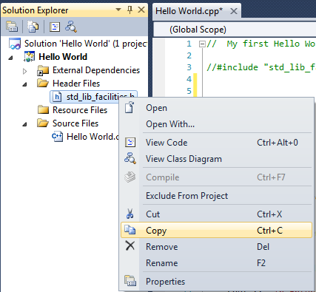
Fig. 11

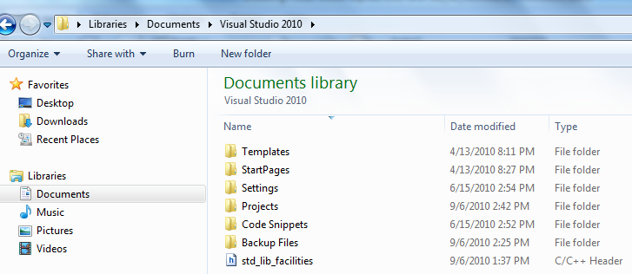
Fig. 12

How to make it work?
- Depending on where you placed your std_lib_facilities .h file, you will need to add one two or three ” ../”. The file was put in the Visual Studio 2010 folder, (fig.12) so we will need to add three ”../ “. Fig.13
- Your program #include should look like this #include "../../../std_lib_facilities.h" fig. 14.
Make sure there are no spaces between “ ” . "../../../std_lib_facilities.h"

Note: If you put a copy in your projects folder it will look like this
#include "../../std_lib_facilities.h"

If you put a copy in your Hello world file folder (folders you create each time to start a new project) it will look like this #include "../std_lib_facilities.h"

If you put a copy in your Hello world file folder (folders where your .cpp file is stored), it will look like this
#include "std_lib_facilities.h"

I hope this helps. Experiment and prove this to yourself

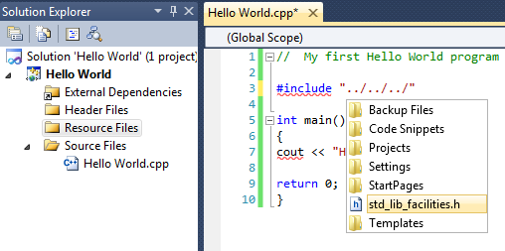
Fig. 13
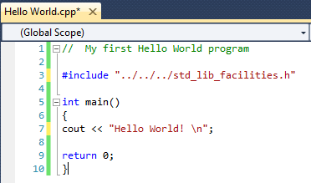
Fig. 14

